Optimal setup of head position with 64ch head-neck coil

MRRC tech team
MR Research Center, Radiology, University of Pittsburgh
@04/19/2022

MR research center is equipped with two multi-channel receiver coils for 3T Prisma scanner; 64ch head-neck and 32ch head coil. 32ch coil is designed for only brain imaging, and 64ch coil is for brain and neck/c-spine. MR image quality could be different for two coils. Multi-channel coil consists of many small coil loops – each one operating a surface coil. Therefore, MR image quality, particularly signal to noise (SNR) is mainly affected by distance between imaging object (e.g., brain) and coil loop which is attached on coil plastic frame in back side. The closer object to the coil loop will make the higher signal. However, closer positioning of a head to coil loop sometimes causes subject’s uncomfortableness, because the coil plastic frame is formed and limits subject head freedom in the inner space. Therefore, when a subject head is positioned in the coil, there are two conditions to be considered; the closeness and the comfortableness.

Coil geometry or dimension; 64ch vs. 32ch coil (Fig. 1)
The 64ch coil covers head and neck, most of channels (42? channels) are dedicated for the head and 12? channels cover for the neck. While the 32ch coil can cover only the head. The dimension of inner volume of two coils are interestingly similar each other, that is, 7.6’’(width)x9’’(height)x9.5’’(depth) and 7.7’’(width)x8.8’’(height)x9.2’’(depth) for the 64ch and 32ch coil, respectively. The 64ch coil has a little higher upper plastic cap which can make higher dimension and allows higher nose position. A big difference between two coils is a shoulder form which blocks head from positioning in deep location into the coil. The shoulder form exists only for the 64ch coil. The 32ch coil without a shoulder foam, the access to deeper coil is feasible so that closer head positioning to the coil top loops are possible.
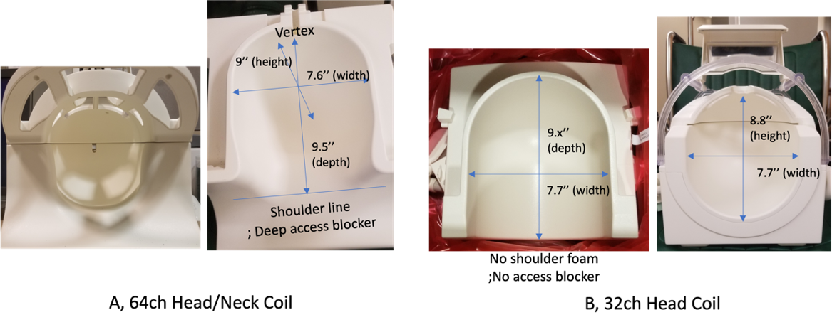 | Figure 1. Inside dimension of 64ch and 32ch coil. The geometry of 64ch coil inside is a little formed to head shape with shoulder form, while that of the 32ch coil is simple cylindrical shape with half sphere cap. This difference makes positioning of a head positioning different for two coils.

MR image SNR comparison between 32ch vs. 64ch coil
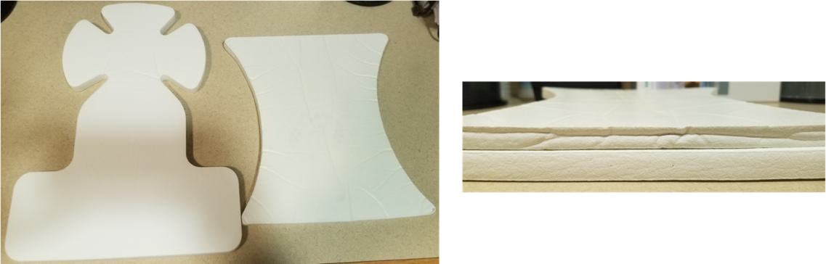 | Figure 2. Head coil pad, (Left panel) – the thick (left one) and the thin pad (right one). Generally, the former is used with 64ch coil and the later is with 32ch coil in typical head coil setting. (Right panel) Top pad is thin, bottom one is thick pad.
Two pads are available for head positioning in the coils. One is contoured and come with Prisma 3T, another one is with Trio 3T(?) – the former is a little thick and harder than the later. The different pad makes head position is a little higher or lower from the coil plastic of bottom.
Experiment of SNR dependency of head position in the coil was done with a subject. Head setup in the coil was done for natural positioning with thin pad (right one in Figure 2) for both 32ch and 64ch coils (Figure 2), that is, a subject laid down back on scanner table and put head into the coil, and had most comfortable position. Laser marker was set to the coil center where there is printed lines on the coil plastic frame. Conventional T1 MPRAGE structural image with two coils were acquired form a subject in single session with two separate runs; particularly, pre-scan normalization turned off and no parallel imaging applied for true coil SNR comparison.
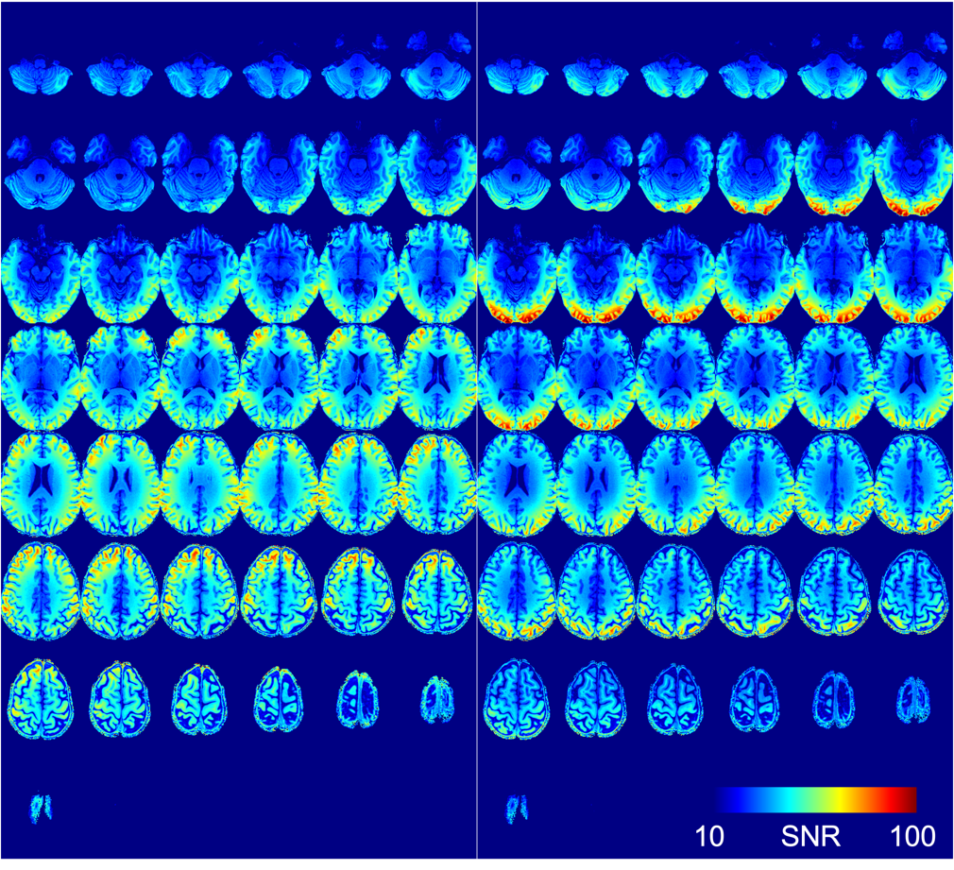 | Figure 3 SNR map of MPRAFGE image acquired by 32ch (left group panel) and 64ch coil (right group). SNR was calculated the ratio of pixel intensity and noise in background of image. The imagee are coregistered using 3D affine transformation. 3D images are sliced in axial view.
SNR map was calculated by image pixel intensity divided by the noise in background in pixel-by-pixel. The images of two coils were co-registered each other to compare SNR at same brain position. SNR map (Figure 3) shows that the 32ch coil produces higher signal in anterior (prefrontal) as well as deep brain region, while the 64ch coil does in posterior region, visual cortex under the experiment condition; In sagittal view, this difference can be visualized more clearly.
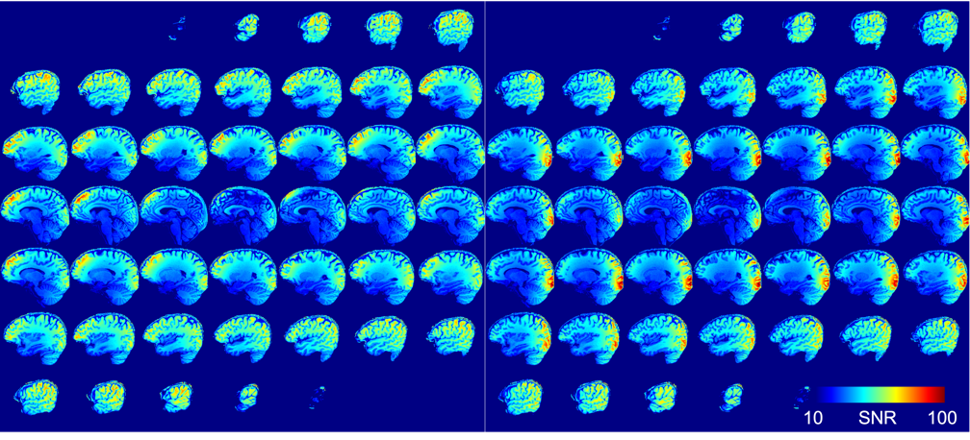 | Figure 4 SNR map of MPRAFGE image acquired by 32ch (left group panel) and 64ch coil (right group). SNR was calculated the ratio of pixel intensity and noise in background of image. The imagee are coregistered using 3D affine transformation. 3D images are sliced in sagittal view.
The ratio of SNR maps of 32ch vs. 64ch coil shows clearly where the 32ch and 64ch coil produces higher signal. Red-yellow-colored regions represent higher signal with 32ch coil, while blue-cyan-colored regions have high signal with 64ch coil.
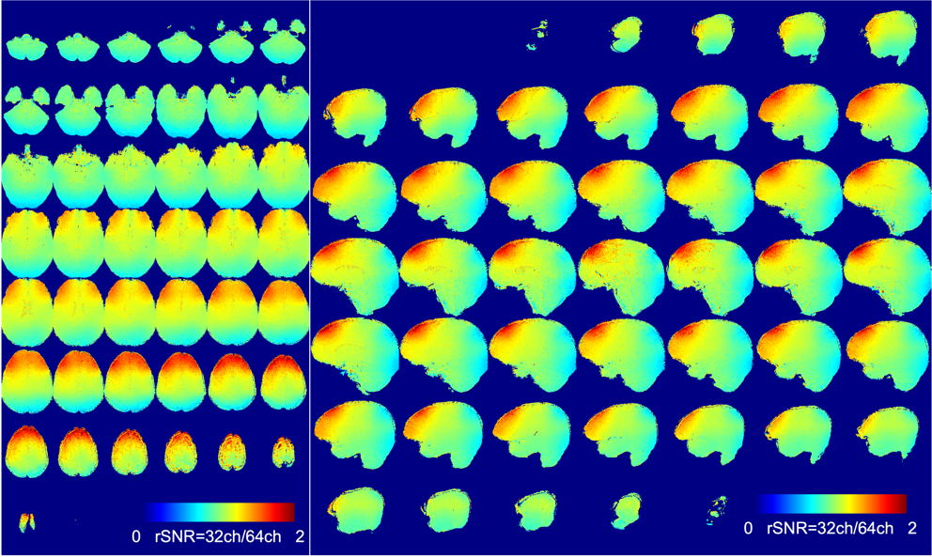 | Figure 5 Ratio of SNR maps of 32ch vs. 64ch coil - read-yellow values indicate high signal with 32ch coil, cyan-blue region does 64ch coil high signal.
At the second SNR measurement with the 64ch coil, two thin (so thick) pads (right one in Figure 2) were used to accommodate the signal in posterior and anterior brain regions – a little lifting the head toward to nose direction. By lifting the head position, the head could be moved in further into 64ch coil which made deeper positioning of head to the coil inside (see Figure 6). The 64ch coil SNR is overall similar to that of 32ch coil (Figures 7, 8 and 9). At top of head 32ch coil shows higher signal, it seems the head top is closer to 32ch coil frame than that in 64ch coil setup.
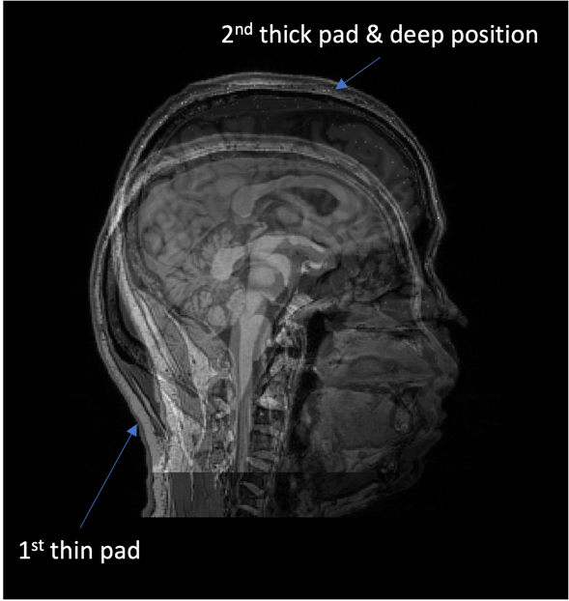 | Figure 6 Head positioning in the 64ch coil. The 1st positioning was done in natural head positioning with thin pad. The 2nd positioning was done by two thin pads and deeper positioning into the coil

Therefore, the head positioning in 64ch coil is important to acquire higher quality MR image - SNR is critical for fMRI BOLD and DTI, for example, with high b value due to the small functional signal or low signal of raw data.

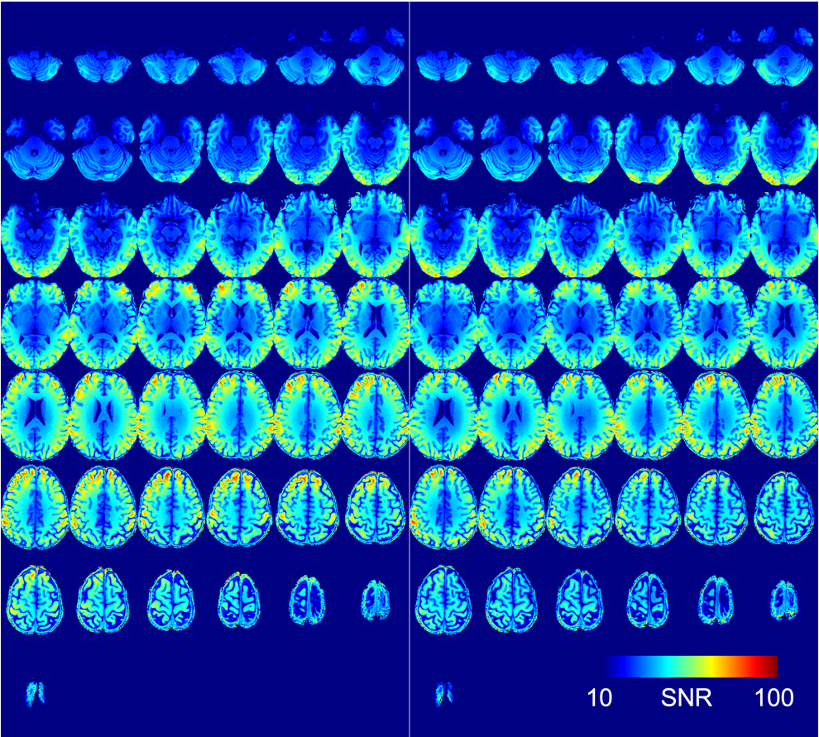 | Figure 7 Axial SNR map of MPRAFGE image acquired by 32ch (left group) and 64ch coil (right group) – two thin pads used. Two 3D volume images are co-registered.

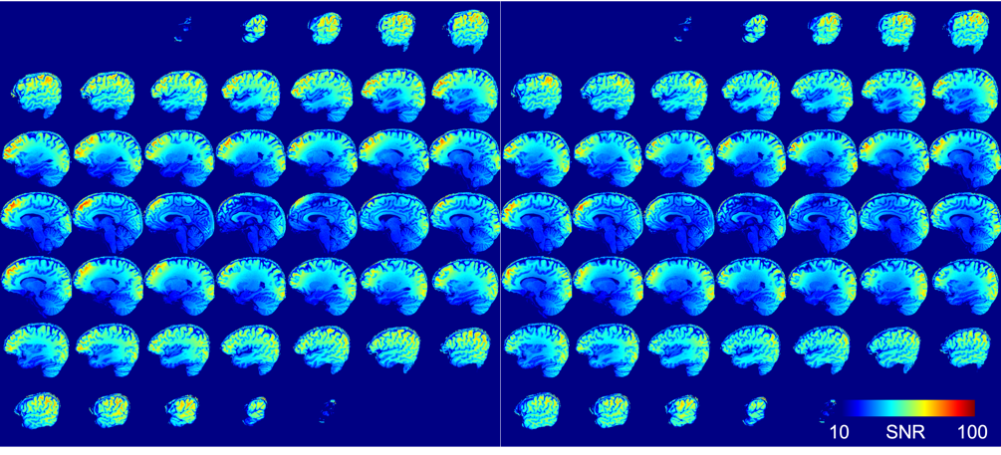 | Figure 8 Sagittal SNR map of MPRAFGE image acquired by 32ch (left group) and 64ch coil (right group) – two thin pads used. Two 3D volume images are co-registered.

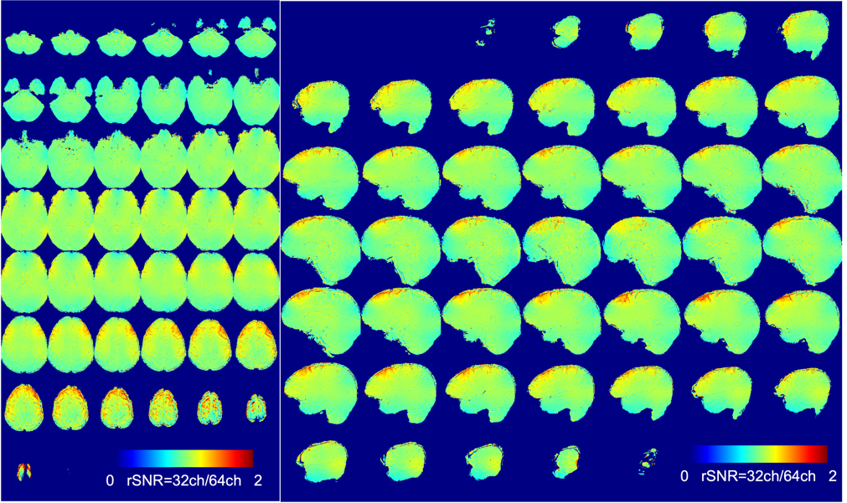 | Figure 9 Ratio of SNR map of 32ch vs. 64ch coil. Overall, two coil’s SNR maps looks similar except very top of head – where the subject head touches the coil frame further with 32ch coil than 64ch coil.

Measuring head position inside of the 64ch coil in MR imaging
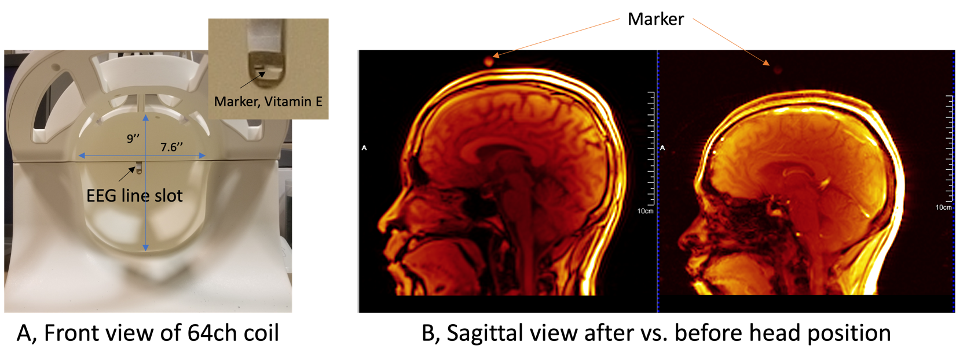
Figure 10 Installation of vitamin E marker on top end of the 64ch coil. A, Front view of the coil. B, Sagittal localizer image with the marker. The marker in image can show the position of head in the coil.

It is good to know where the subject’s head is positioned in the coil. Therefrom, the researcher can estimate degree of gross fMRI or DWI signal, in frontal and deep brain. If needed, the subject could be asked to move further in the coil, particularly 64ch coil. There is a slot for EEG line pathway at top end of the 64ch coil – it is aligned to the center of magnet (or the coil) in longitudinal axis. One vitamin E capsule fits into the slot and set as a marker of the coil top end (Figure 10A). Localizer sagittal slice orientation is set to isocenter and without pre-scan normalization, the marker can be visualized clearly right after the table setting (Figure 10B). The natural head position is ~20 mm away from the 64ch coil top end. From this simple setting, the head position inside of the coil can be easily and quickly figured out and if needed, the head can be positioned further into the coil. It is noted, however, this post-checking of head position after the coil setting may not be practical because head-setting and imaging need to be repeated with operator’s coming in/out the scanner room, which will make the study longer.

Thumb rule at head positioning in the 64ch coil
First, two thin pads or single pad with thickness comparable is desirable for head setting into the 64ch coil at Prisma 3T, as long as a subject feels comfortable without the nose touching to the top coil cover. Second, it is suggested that the head is put all the way to back to coil top end, as long as a subject is comfortable. It is noted that the higher head position with thicker pad could make the neck a little straight, which makes the subject feel uncomfortable – with a little neck bend back makes feel better, that is, natural neck angle. In this case, one idea could be making the body position higher using, for example, adding thin mattress to the subject back. Lower head position with a thin pad, a subject can’t push the head to further into coil. To help subject push the head deep to the coil end, the head position needs to be higher than that made by single thin pad.
In conclusion, set two thin pads to put head a little high, and add thin table mattress to give more comfortable neck angled position, if with two thin pads.

Experiences
AC - The majority of subjects are positioned as far as we can into the head coil. The ones that are not positioned as far normally have a reason. They have neck or back issues, their head is larger than average, or they have a short neck. These subjects would not benefit from an image analysis verifying what we already know; that they are low in the coil because we placed them low in the coil. For pediatric cases or subjects that have smaller than average heads, we can certainly adopt a 2 head pad solution. I think being aware of the issue and highlighting it to technologists and lab users should be sufficient to fix this problem.

